**Connecting Fabrics components with Oracle DB**

Before establishing the connection, we need to create a **workspace** first.

**Lakehouse :**

A **Lakehouse** is a modern data architecture that combines the **scalability of data lakes** with the **reliability and performance of data warehouses**.It allows structured and unstructured data to coexist in a single system using open formats like **Delta Lake**.This unified platform supports **BI, SQL analytics, and machine learning** directly on large volumes of data.

Creating **Lakehouse** in the workspace.

1. Click **New Item** and select **Lakehouse** and give a name to it.

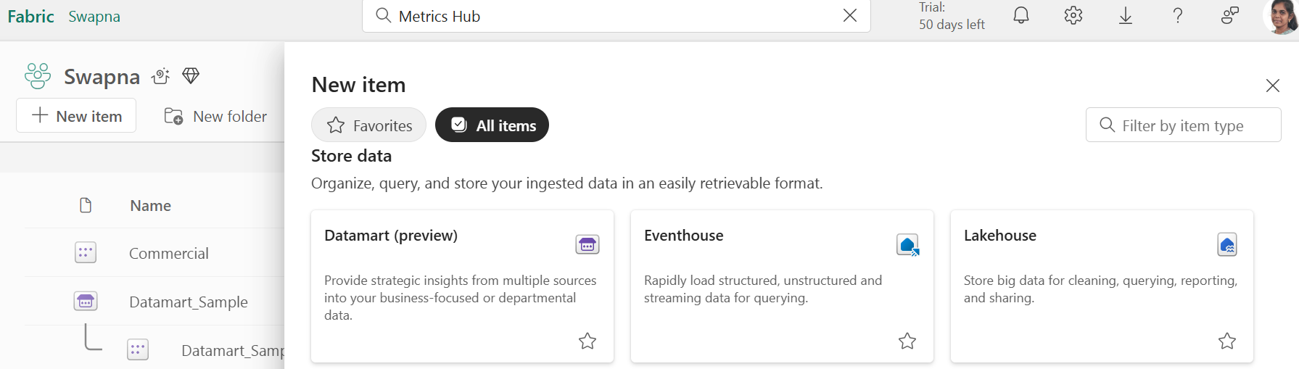

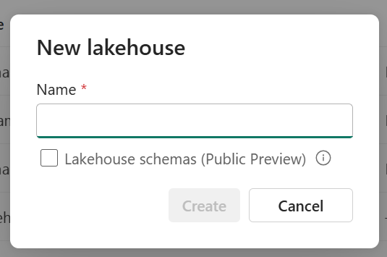

1. Then the interface of the Lakehouse will appear. Then select **Get data** at the top of the Lakehouse.   
     
   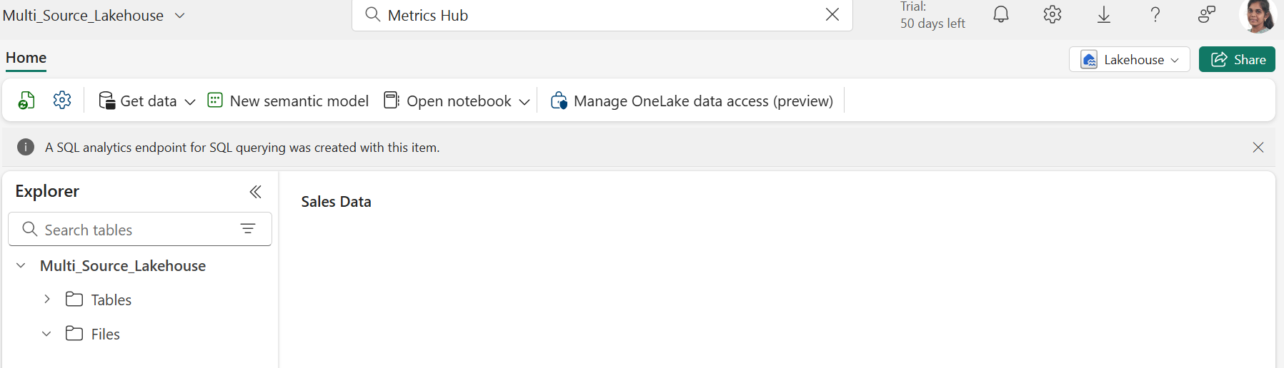
2. Select any of the way to connect oracle . The ways are shown in below image.

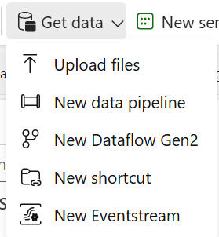

1. For Example **data pipeline**. Give name to the data pipeline. Then use copy data activity then give source as a oracle and give destination as recently created Lakehouse. Give the credentials of the oracle db like connection name, username and password. Then destination is lakehouse.

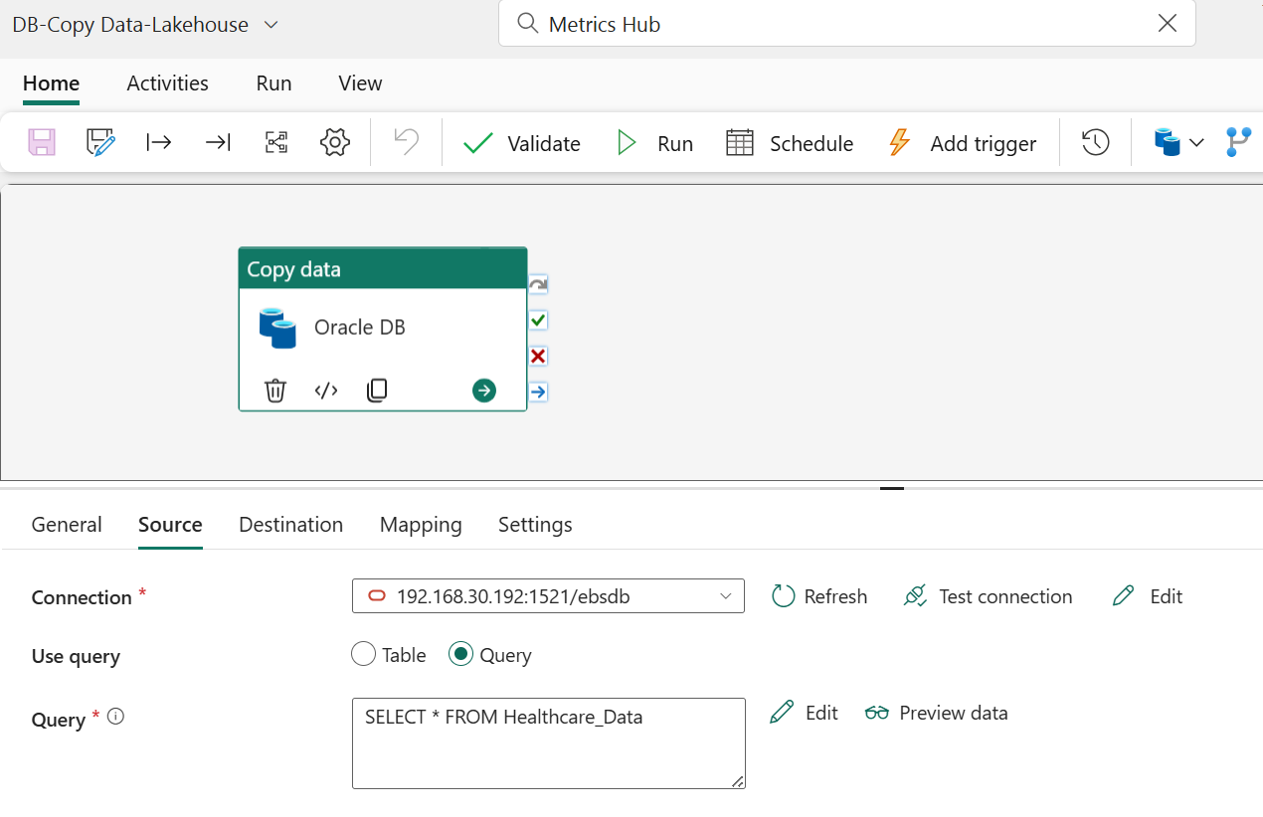

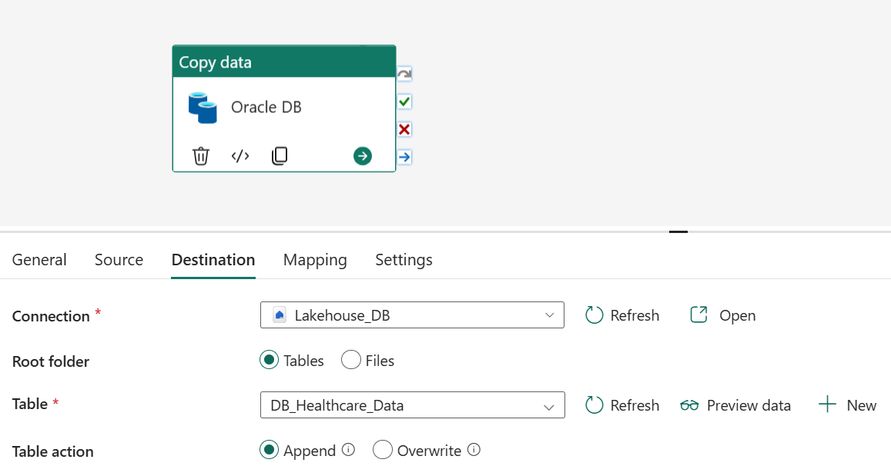

**Warehouse :**

A **Data Warehouse** is a centralized repository designed for **storing, managing, and analyzing structured data** from various sources. It supports **high-performance querying and reporting**, making it ideal for business intelligence and decision-making. Data is typically **cleaned, transformed, and organized** into schemas like star or snowflake for efficient access.

1. Create the **Warehouse** in the same workspace and give a name to it.

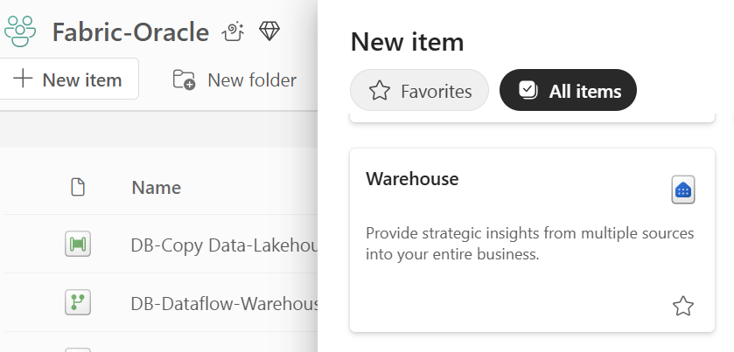

1. Select the way to connect from oracle . For Example under Get data select the **Dataflow.**

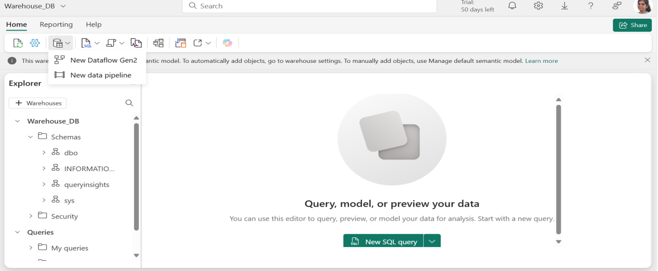

1. Open the Dataflow and give a name to it after creating at the top we can see the get data from there select **more** and search for the Oracle database.

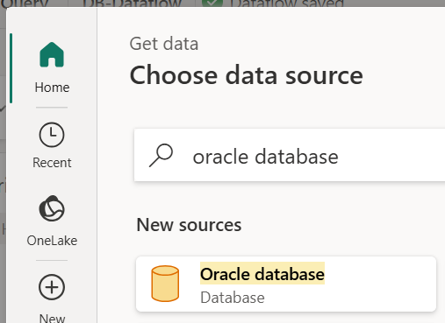

1. Then enter the credentials of the database like connection name, username and password. We can **transform data** if we use dataflow for connecting any of the source. Then give the **destination as warehouse** then **publish** it.

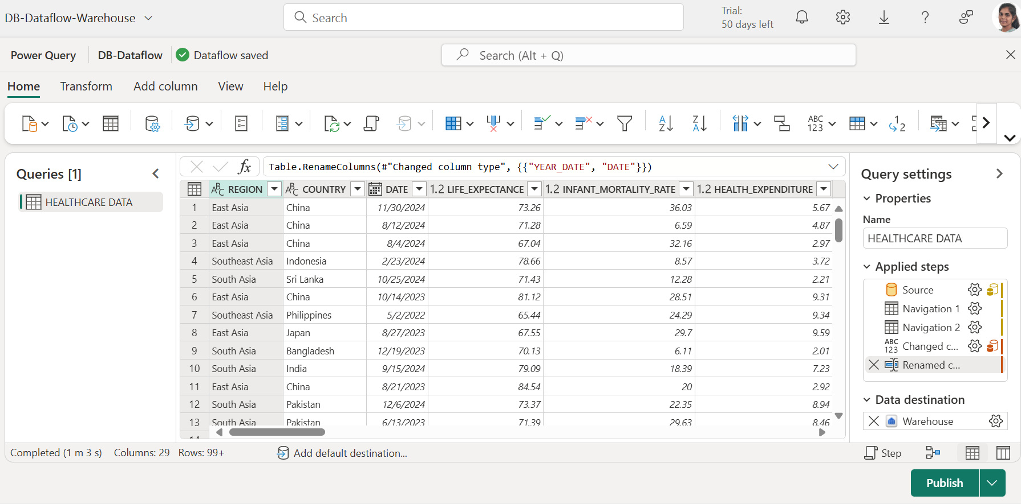

**KQL Databses :**

A **KQL (Kusto Query Language) Database** is a cloud-based, read-optimized database used primarily for **log and telemetry data analysis** in Azure Data Explorer. It enables fast, scalable querying of large volumes of structured, semi-structured, and unstructured data. KQL databases are ideal for **real-time analytics, monitoring, and diagnostics** across applications and services.

1. Create the **KQL Database** in the same workspace and give a name to it.

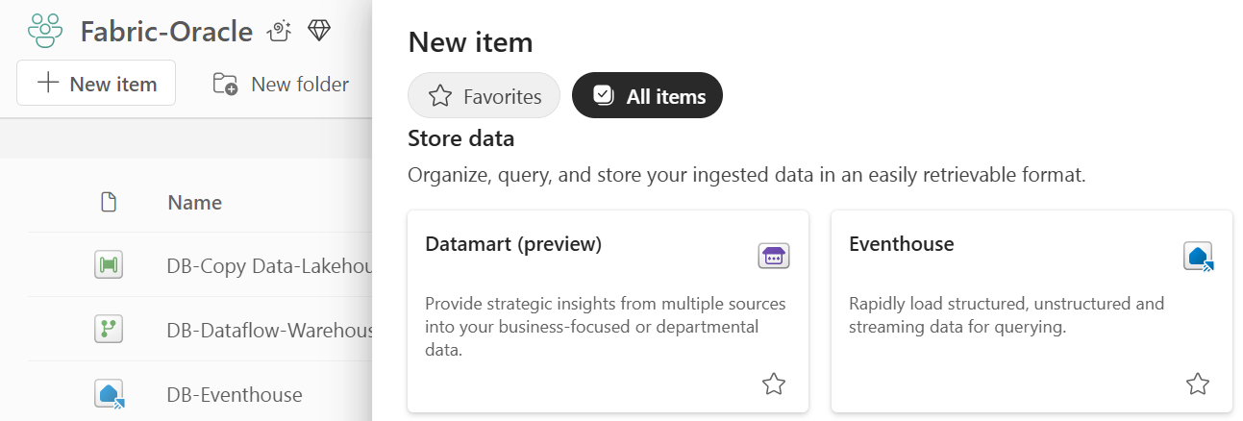

1. After creating the eventhouse under **KQL Database** there is **KQL Query set** there at the top we can see the get data from there we can select any of the way to connect for example **pipeline**.

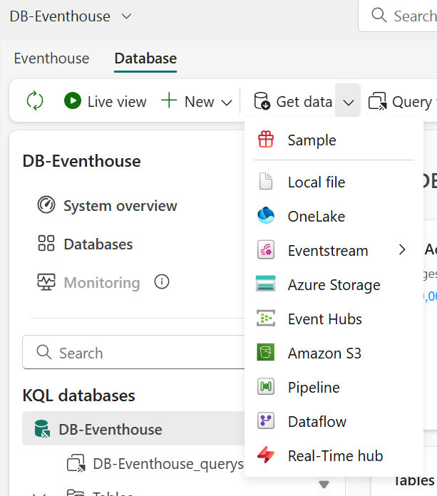

1. In Pipeline add the source as a **Oracle DB** with credentials and destination as a KQL Database. Before that we have to create a **table** with columns in oracle related then push the data into it and **Run**.

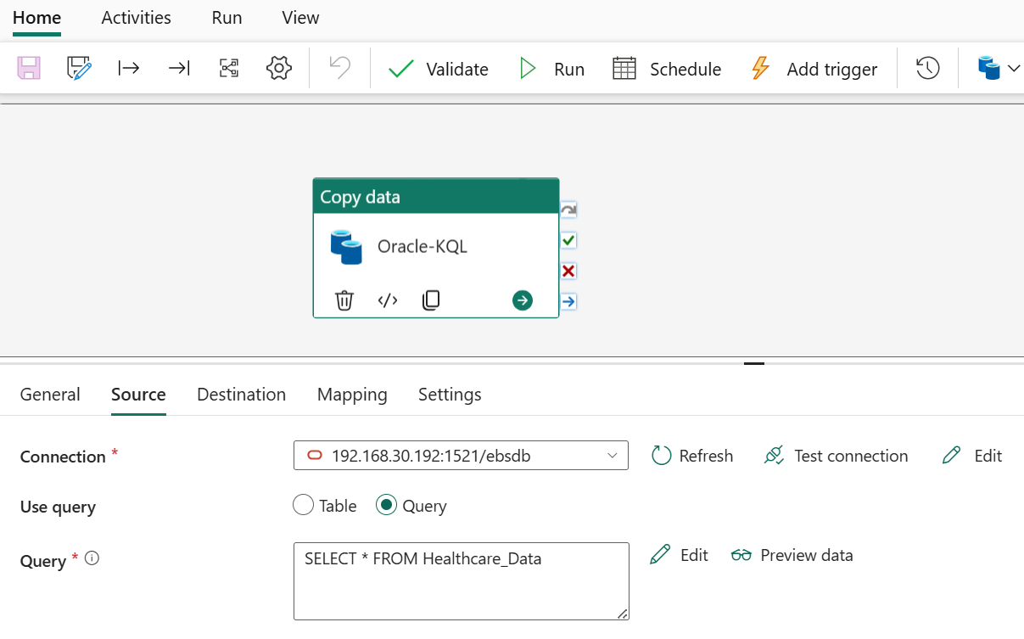

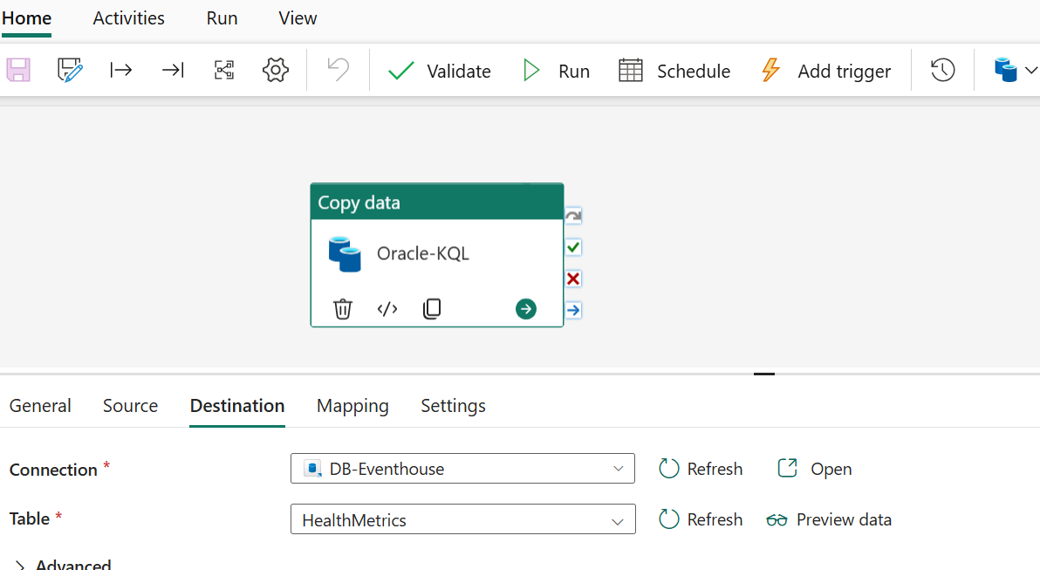

**SQL Database :**

In Microsoft Fabric, a **SQL Database** refers to a **structured, relational database** built on top of the Fabric platform, enabling users to store and query data using **Transact-SQL (T-SQL)**. It supports **enterprise-grade analytics**, seamless integration with Power BI, and compatibility with existing SQL-based tools.

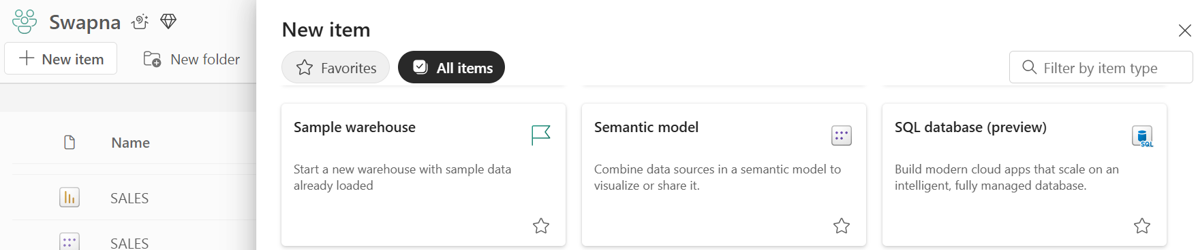

1. Create the **SQL Database** in the same workspace and give a name to it.

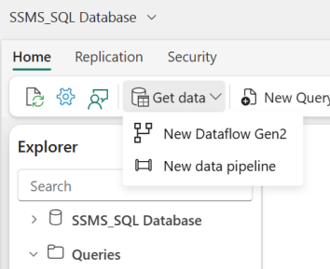

1. Select the way the you want to connect **Oracle**. Example Pipeline then give the **source** as a Oracle and **destination** as a **SQL Database** and select the **auto create** the table if we have one we can select.

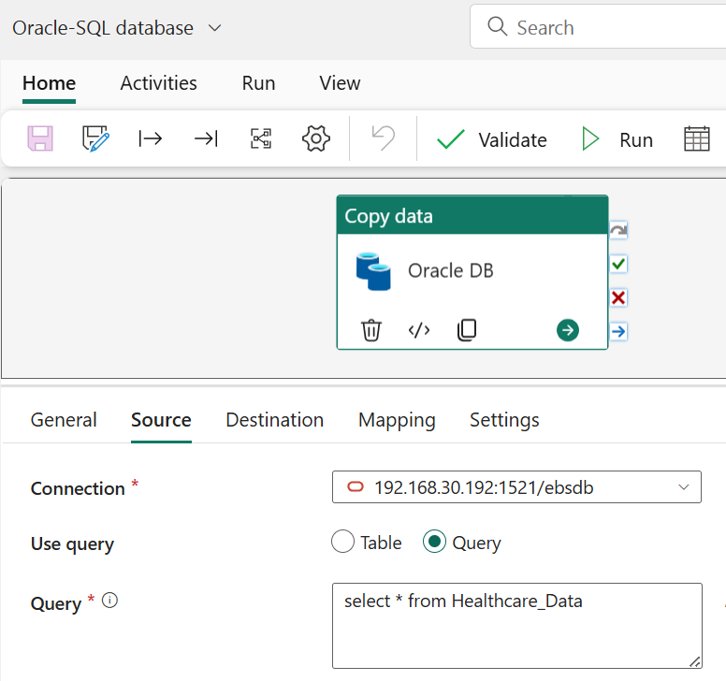

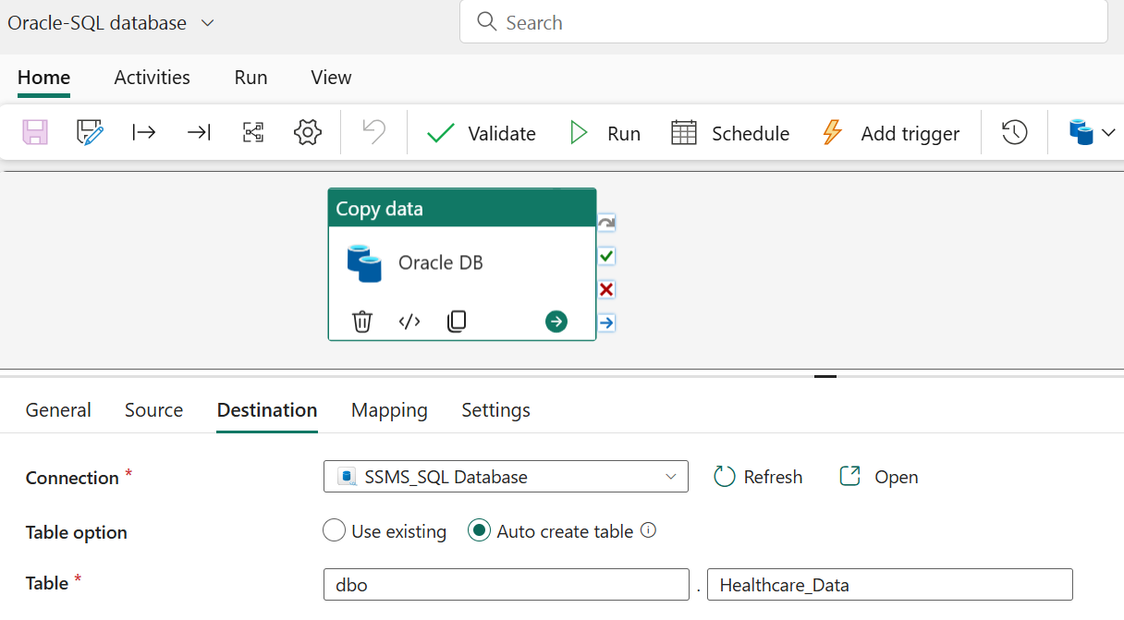

**Datamarts :**

In Microsoft Fabric, **Datamarts** are **self-service analytics solutions** that combine data ingestion, preparation, and storage in a single, no-code or low-code environment. They are built on a fully managed **SQL database**, allowing users to create relational data models and run T-SQL queries directly. Datamarts are ideal for **business users and analysts** to explore

data, build reports, and share insights without relying heavily on IT teams.

1. Create the  **Datamart** in the same workspace and give a name to it.

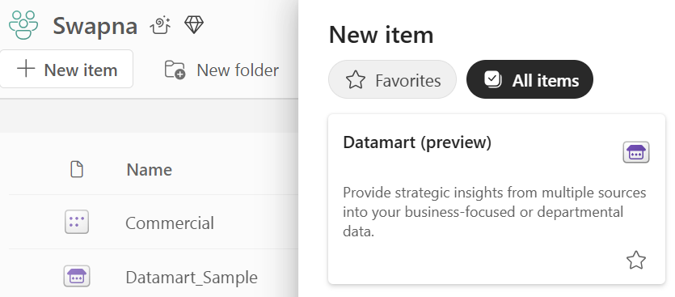

1. Select Get Data at the top and then search for **Oracle database** then give the credentials then it will appear in datamarts.

